Good afternoon everyone. My name is Uma Suryavanshi.
Today I’ll be presenting my Nova Cart Business Performance Dashboard. The objective of this dashboard is to understand the overall business performance and identify key areas affecting sales, profitability, customer satisfaction, and operational performance. I’ll walk through the key insights from the data and then discuss the business recommendations based on those findings.
So, let’s begin with the dashboard.
Starting with the key performance indicators, NovaCart generated ₹33 million in total sales with ₹2.69 million in profit from 550 orders. The overall profit margin is around 8.2%, with an average customer rating of 4.3 out of 5. The average delivery time is more than 5 days, while the return rate is 30.18%, which is an area that needs attention. These KPIs give us a quick overview of the company's overall sales, profitability, customer satisfaction, delivery performance, and returns.
Monthly Sales Trend
“Now, let's look at the monthly sales trend to understand how sales performed throughout the year.
We can see that sales fluctuate across the year rather than following a consistent upward trend. July and September are the strongest months, with sales of around ₹3.5 million, while February records the lowest sales at around ₹2 million.
This indicates some variation in customer demand throughout the year. From a business perspective, Nova Cart can use this pattern for better inventory planning and targeted marketing during high-demand periods.
Now let's move to sales and profit by category to understand which product categories are contributing most to the business.”
Sales & Profit by Category
“Here we can see an important difference between sales and profitability.
Furniture is the strongest-performing category, generating around ₹8.8 million in sales and ₹1.5 million in profit. On the other hand, Electronics generates almost the same sales, around ₹8.6 million, but only ₹0.3 million in profit.
So, this tells us that high sales don't necessarily mean high profitability. Electronics and Fashion generate good revenue, but their profitability is comparatively low.
From a business perspective, Nova Cart should continue investing in Furniture while reviewing pricing, costs, and discount strategies for Electronics and Fashion.”
Sales Distribution by Region
“Next, this chart shows how sales are distributed across the four regions.
South contributes the highest sales at around ₹9.34 million, followed by North at ₹8.33 million. East and West contribute around ₹7.65 million each.
The important point here is that sales are fairly well distributed across regions, so Nova Cart isn't heavily dependent on one particular market.
However, South's high sales don't necessarily mean it's the most profitable region, which we can see in the next chart.”
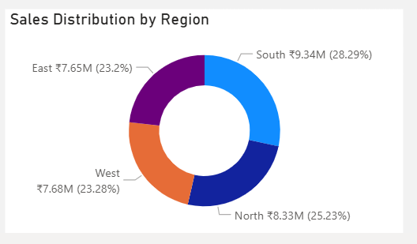

Profit by Region
“When we look at profit by region, we get a slightly different picture.
North generates the highest profit at around ₹0.78 million, while South, despite having the highest sales, generates the lowest profit at around ₹0.47 million.
This again shows that revenue and profitability are not always aligned.
Therefore, Nova Cart should investigate the South region to understand what is reducing its profitability, such as discounting, product mix, or other operational factors.”
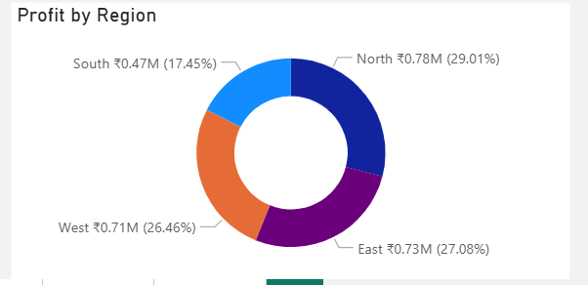

Profit Margin % by Region & Category
“This chart takes the analysis one step further by looking at profit margin rather than just total profit.
Furniture consistently has the highest profit margins across regions, while Electronics and Fashion operate with much lower margins, generally around 2 to 5 percent.
This tells us that Furniture is not only generating high sales and profit, but is also converting its sales into profit more efficiently.
Nova Cart should therefore continue prioritizing Furniture while looking for ways to improve margins in Electronics and Fashion through pricing, cost control, and discount optimization.”
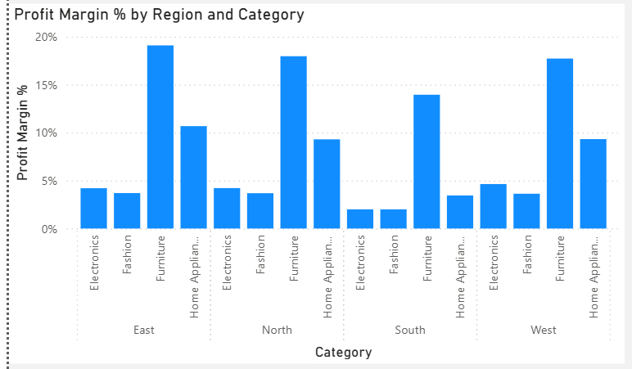

Average Rating vs Delivery Days
“Next, let's look at the relationship between delivery time and customer satisfaction.
Customer ratings remain around 4.7 when delivery takes 2 to 5 days. However, once delivery goes beyond 6 days, the rating drops significantly to around 3.5 and remains low for longer delivery times.
This suggests that longer delivery times are strongly associated with lower customer ratings.
From a business perspective, Nova Cart should focus on reducing delivery delays and maintaining delivery within the 2 to 5 day range wherever possible, as faster delivery can contribute to better customer satisfaction.”
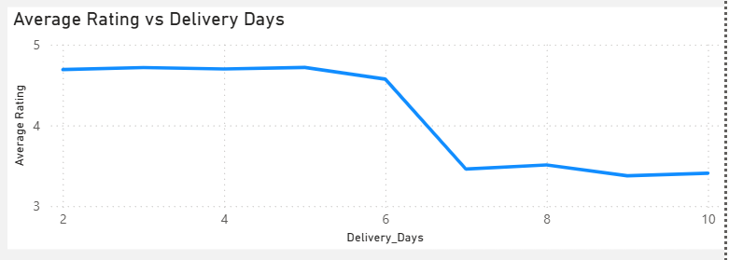

Impact of Discount on Average Sales & Profit
“Next, we can see the impact of discounts on average sales and profit.
As the discount range increases, average sales generally increase, reaching around ₹63K at the highest discount range. However, average profit decreases from around ₹7K to ₹3K.
This shows a clear trade-off: higher discounts can help increase sales, but they reduce profitability.
Therefore, Nova Cart should avoid excessive discounting and identify a discount range that balances sales growth with healthy profit margins.”
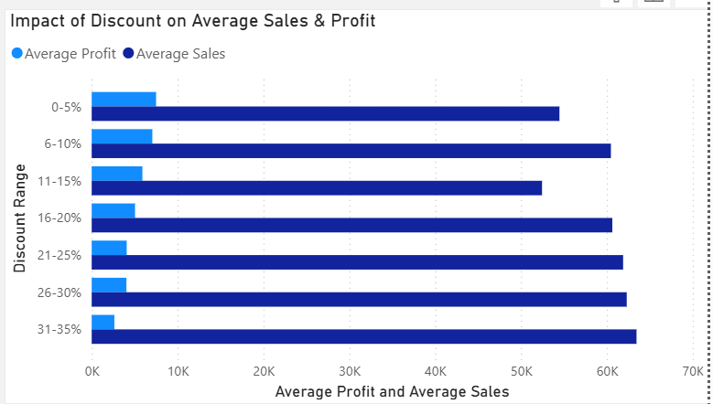

Return Rate by Region
“Now let's look at the return rate across regions.
The South region has the highest return rate at around 50.34%, which is significantly higher than East at 26.77%, North at 24.64%, and West at 17.39%.
This makes South a clear area of concern.
The dashboard tells us where the problem is, but not the exact reason behind it. So NovaCart should investigate whether the high returns are related to product quality, delivery issues, incorrect products, or customer expectations.”
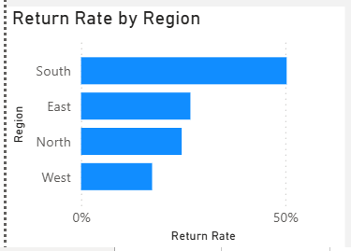

Return Status
“Finally, this chart gives us the overall return picture.
NovaCart has a 30.18% return rate, with 166 returned orders out of 550 orders. This means that almost one out of every three orders is being returned, which can have an impact on both profitability and operational efficiency.
Since South already has the highest return rate, it would be a priority area for further investigation and corrective action.”
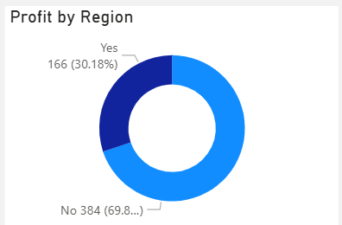

Overall Insights & Business Implications
“Overall, the dashboard highlights a few important areas for Nova Cart.
First, Furniture is the strongest-performing category, while Electronics and Fashion need improvement in profitability.
Second, South generates the highest sales but has the lowest profit and the highest return rate, making it an important region to investigate.
Third, longer delivery times are associated with lower customer ratings, so delivery performance should be improved.
And finally, higher discounts increase average sales but reduce average profit, so discounting needs to be managed strategically.”

Closing
“Based on these findings, NovaCart can focus on improving profitability, optimizing discount strategies, reducing delivery delays, and addressing the high return rate, particularly in the South region.
These improvements can help the business achieve more sustainable growth while maintaining customer satisfaction.
That concludes my analysis. Thank you.”

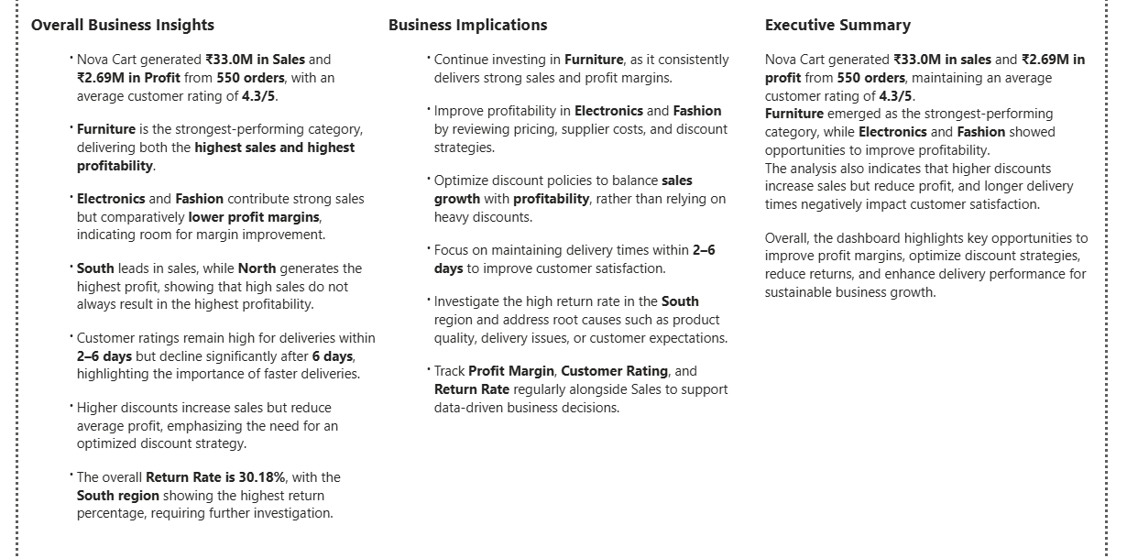
Visual | Business question it answers
KPI Cards | What is NovaCart's overall business performance?
Monthly Sales Trend | How does sales performance change across the year? Are there strong or weak months?
Sales & Profit by Category | Which product categories generate the most revenue and profit? Does high sales translate into high profit?
Sales Distribution by Region | Which regions contribute the most to total sales? Is NovaCart dependent on any particular region?
Profit by Region | Which regions are actually generating the most profit?
Profit Margin % by Region & Category | Which category-region combinations convert sales into profit most efficiently?
Sales by Category & Region | Which categories perform strongly within each region? Where are the strongest category-region markets?
Profit by Category & Region | Which category-region combinations are actually the most profitable?
Impact of Discount on Avg Sales & Avg Profit | Are higher discounts increasing sales enough to justify the reduction in profit?
Average Rating vs Delivery Days | Does delivery speed affect customer satisfaction?
Return Rate / Return Status | How significant are returns, and which regions/categories may require attention?
Executive Summary | What are the most important findings and business priorities from the entire analysis?

1. Overall →
"How is NovaCart doing?"
→ KPIs
2. Sales →
"Where is revenue coming from?"
→ Monthly Sales, Category, Region
3. Profitability →
"Are we actually making money efficiently?"
→ Profit by Region, Profit Margin, Category × Region
4. Pricing →
"Is our discount strategy helping or hurting us?"
→ Discount vs Sales & Profit
5. Customer Experience →
"Are customers satisfied, and what affects satisfaction?"
→ Rating vs Delivery Days
6. Operations →
"Where are we losing business through returns?"
→ Return Rate
7. Action →
"So what should NovaCart do?"
→ Recommendations

📌 Overall Business Insights
- NovaCart generated ₹33.0M in Sales and ₹2.69M in Profit from 550 orders, with an average customer rating of 4.3/5.
- Furniture is the strongest-performing category, delivering both the highest sales and highest profitability.
- Electronics and Fashion contribute strong sales but comparatively lower profit margins, indicating room for margin improvement.
- South leads in sales, while North generates the highest profit, showing that high sales do not always result in the highest profitability.
- Customer ratings remain high for deliveries within 2–6 days but decline significantly after 6 days, highlighting the importance of faster deliveries.
- Higher discounts increase sales but reduce average profit, emphasizing the need for an optimized discount strategy.
- The overall Return Rate is 30.18%, with the South region showing the highest return percentage, requiring further investigation.

💡 Business Recommendations/Implications
- Continue investing in Furniture, as it consistently delivers strong sales and profit margins.
- Improve profitability in Electronics and Fashion by reviewing pricing, supplier costs, and discount strategies.
- Optimize discount policies to balance sales growth with profitability, rather than relying on heavy discounts.
- Focus on maintaining delivery times within 2–6 days to improve customer satisfaction and retention.
- Investigate the high return rate in the South region and address root causes such as product quality, delivery issues, or customer expectations.
- Track Profit Margin, Customer Rating, and Return Rate regularly alongside Sales to support data-driven business decisions.

If they ask for your final conclusion in the presentation:
"Overall, NovaCart is achieving strong sales performance, but the analysis shows opportunities to improve profitability, optimize discount strategies, reduce returns, and enhance customer satisfaction through faster deliveries. Focusing on these areas can support sustainable business growth while maintaining a positive customer experience."

Executive Summary
The NovaCart Business Performance Dashboard provides a comprehensive overview of the company's sales, profitability, customer satisfaction, delivery performance, discount strategy, and return trends. During the analysis period, NovaCart generated ₹33.0M in sales and ₹2.69M in profit across 550 orders, maintaining an average customer rating of 4.3/5.
The analysis identified Furniture as the strongest-performing category in terms of both sales and profitability, while Electronics and Fashion showed strong revenue but comparatively lower profit margins. Customer satisfaction was closely linked to delivery performance, with ratings declining noticeably for deliveries taking longer than six days. Additionally, higher discount levels increased sales but reduced average profitability, indicating the need for an optimized discount strategy. The dashboard also highlights a 30.18% return rate, with the South region requiring further investigation due to its relatively high returns.
Overall, the dashboard enables management to make data-driven decisions by identifying opportunities to improve profitability, optimize pricing and discount strategies, enhance delivery efficiency, and reduce product returns to support sustainable business growth.

Executive Summary
NovaCart generated ₹33.0M in sales and ₹2.69M in profit from 550 orders, maintaining an average customer rating of 4.3/5. Furniture emerged as the strongest-performing category, while Electronics and Fashion showed opportunities to improve profitability. The analysis also indicates that higher discounts increase sales but reduce profit, and longer delivery times negatively impact customer satisfaction. Overall, the dashboard highlights key opportunities to improve profit margins, optimize discount strategies, reduce returns, and enhance delivery performance for sustainable business growth.

📈 1. Monthly Sales Trend
Insight
- Sales fluctuate throughout the year rather than growing steadily.
- July (₹3.49M) and September (₹3.50M) are the strongest months.
- February (₹2.00M) records the lowest sales.
Why it matters
This indicates seasonal demand. NovaCart should prepare inventory and marketing campaigns before peak months and investigate the reasons behind the February dip.

📊 2. Sales & Profit by Category
Insight
- Furniture is NovaCart's best-performing category, generating the highest sales (₹8.8M) and highest profit (₹1.5M).
- Electronics has sales almost equal to Furniture (₹8.6M) but earns only ₹0.3M profit.
- Fashion also shows high sales but relatively low profit.
- Home Appliances has the lowest sales but still generates better profit than Electronics and Fashion.
Why it matters (Presentation)
High sales do not always mean high profitability. Furniture is the most profitable category, while Electronics and Fashion generate strong revenue but much lower profit. This suggests that pricing, discounts, product costs, or margins in these categories should be reviewed to improve profitability.
Business implication
- Continue investing in Furniture as a high-performing category.
- Analyze Electronics and Fashion to identify why their profit margins are low despite strong sales.
- Review pricing strategy, supplier costs, and discount policies for these categories.

📊 3. Profit by Region
Insight
- North generates the highest profit (₹0.78M, 29.01%).
- East follows closely with ₹0.73M (27.08%).
- West contributes ₹0.71M (26.46%), showing performance similar to East.
- South records the lowest profit (₹0.47M, 17.45%), despite having the highest sales.

Why it matters (Presentation)
This chart reveals that the South region leads in sales but not in profit. In contrast, the North region generates the highest profit with lower sales than the South. This indicates that higher sales do not necessarily translate into higher profitability. The South region may be experiencing lower profit margins due to factors such as higher discounts, operational costs, or product mix.
⭐ This is one of the strongest insights in your dashboard because it connects Sales by Region with Profit by Region.

Business Recommendations
- Investigate why the South region generates the highest sales but the lowest profit by reviewing discount policies, operating costs, and product profitability.
- Study the North region's business strategy to understand how it achieves the highest profitability and identify practices that can be applied to other regions.
- Focus on improving profit margins in the South rather than only increasing sales.

Possible Interview Questions
Q1. Why do you think South has the highest sales but the lowest profit?
Answer:
The dashboard doesn't provide cost-level details, so I cannot conclude the exact reason. However, possible factors include higher discounts, increased operating costs, lower-margin products, or higher return-related expenses. This would require further investigation.

Q2. What is the key takeaway from comparing the Sales and Profit by Region charts?
Answer:
Revenue alone is not a complete measure of business performance. Comparing sales with profit helps identify regions where revenue is strong but profitability is weak, allowing management to focus on improving margins instead of only increasing sales.

⭐ One thing I really like
This pair of visuals (Sales by Region + Profit by Region) creates a story:
Sales tell us where revenue comes from.
Profit tells us where the business actually earns money.

📊 4. Sales Distribution by Region
Insight
- South contributes the highest sales (₹9.34M, 28.29%).
- North follows with ₹8.33M (25.23%).
- West (₹7.68M, 23.28%) and East (₹7.65M, 23.20%) contribute almost equally.
- Sales are fairly well distributed across all four regions, with no single region contributing more than 30% of total sales.

Why it matters (Presentation)
This chart shows that NovaCart has a balanced regional presence rather than relying heavily on a single market. While the South leads in sales, the difference between regions is not significant, reducing the business risk of depending on one region for revenue.
However, when this chart is compared with Profit by Region, we notice that the South generates the highest sales but the lowest profit, indicating that higher revenue is not translating into higher profitability.

Business Recommendations
- Maintain the strong sales performance in the South, but focus on improving its profit margins.
- Continue expanding in the North, which demonstrates strong profitability despite slightly lower sales.
- Since sales are well distributed across regions, continue balanced regional expansion instead of relying on a single market.

Possible Interview Questions
Q1. Why did you use a donut chart here?
Answer:
A donut chart is effective for showing the percentage contribution of each region to total sales, making it easy to compare regional distribution.

Q2. What is the most important takeaway from this chart?
Answer:
The key takeaway is that NovaCart has balanced sales across all regions. However, comparing this with the Profit by Region chart reveals that the highest-selling region is not the most profitable, highlighting an opportunity to improve margins.

📊 5. Profit Margin % by Region & Category
Insight
- Furniture achieves the highest profit margin across all regions, with the East (19.1%) and North (18.0%) performing exceptionally well.
- South records the lowest Furniture profit margin (14.0%), although it still outperforms the other product categories.
- Electronics and Fashion consistently have the lowest profit margins (around 2–5%) across all regions.
- The chart shows that profitability varies not only by category but also by region, highlighting differences in business efficiency.

Why it matters (Presentation)
This visual measures how efficiently each category converts sales into profit. While the Furniture category consistently delivers strong profit margins, Electronics and Fashion generate much lower margins despite contributing significant sales. This suggests that NovaCart should focus not only on increasing sales but also on improving profitability through better pricing, cost control, and product mix.

Business Recommendations
- Continue prioritizing the Furniture category, as it consistently delivers the highest profit margins across all regions.
- Investigate the low margins in Electronics and Fashion by reviewing pricing strategies, supplier costs, and discount policies.
- Study the East region's Furniture performance to identify best practices that can be replicated in regions with lower profit margins, particularly the South.
- Regularly monitor Profit Margin alongside Sales and Profit to ensure revenue growth is translating into healthy business profitability.

Possible Interview Questions
Q1. Why did you include Profit Margin in the dashboard?
Answer:
Sales and Profit show business performance, but Profit Margin indicates how efficiently the company converts revenue into profit. It helps identify categories that are truly profitable rather than just generating high sales.
Q2. What is the key takeaway from this chart?
Answer:
The key takeaway is that Furniture is NovaCart's most efficient and profitable category, while Electronics and Fashion require attention to improve their margins. This helps management focus on profitability instead of only revenue growth.

📊 6. Impact of Discount on Average Sales & Average Profit
Insight
- Higher discount levels are associated with higher average sales.
- However, average profit steadily declines as discounts increase.
- The highest discount range (31–35%) generates the highest average sales (63K) but the lowest average profit (3K).
- Lower discount ranges (0–10%) generate comparatively lower sales but significantly higher profits.

Why it matters (Presentation)
This visual highlights the trade-off between sales growth and profitability. Offering larger discounts successfully attracts more purchases and increases sales, but it also reduces the profit earned on each order. This indicates that aggressive discounting can drive revenue while negatively affecting overall business profitability.

Business Recommendations
- Identify an optimal discount range that balances both sales growth and profitability.
- Avoid offering high discounts as a default pricing strategy.
- Use larger discounts only during targeted campaigns, seasonal sales, or inventory clearance.
- Monitor the profitability of promotional campaigns instead of evaluating them based only on sales growth.

Possible Interview Questions
Q1. What is the biggest takeaway from this chart?
Answer:
Higher discounts increase sales but reduce profitability. NovaCart should focus on finding the discount level that maximizes both revenue and profit rather than simply offering the largest discounts.

Q2. Does this mean NovaCart should stop giving discounts?
Answer:
No. Discounts are effective in driving sales, but they should be used strategically. The objective is to optimize discounts so they increase customer purchases without significantly reducing profit margins.

📊 7. Average Rating vs Delivery Days
Insight
- Orders delivered within 2–6 days receive consistently high customer ratings of around 4.6–4.7.
- Customer ratings drop sharply once delivery time exceeds 6 days.
- Deliveries taking 7–10 days receive ratings between 3.4–3.5, indicating lower customer satisfaction.
- The chart clearly shows a negative relationship between delivery time and customer rating.

Why it matters (Presentation)
This visual demonstrates that delivery speed directly influences customer satisfaction. Customers are generally satisfied when orders arrive within six days, but longer delivery times lead to a noticeable decline in ratings. Faster deliveries can therefore improve customer experience, strengthen brand perception, and encourage repeat purchases.

Business Recommendations
- Aim to keep average delivery time within 2–6 days to maintain high customer satisfaction.
- Investigate operational delays causing deliveries beyond six days.
- Improve logistics planning, warehouse efficiency, and courier performance to reduce delivery times.
- Track delivery performance regularly, as improving delivery speed can positively impact customer ratings and retention.

Possible Interview Questions
Q1. What relationship does this chart show?
Answer:
The chart shows a clear negative relationship between delivery days and customer ratings. As delivery time increases beyond six days, customer satisfaction declines significantly.

Q2. Why is this insight important for NovaCart?
Answer:
Customer ratings directly influence repeat purchases and brand reputation. By reducing delivery times, NovaCart can improve customer satisfaction, increase loyalty, and strengthen its competitive position.

📊 8. Return Status / Return Rate by Region
Insight
- Overall, 30.18% of orders were returned, while 69.82% were successfully retained.
- The South region records the highest return rate (50.34%), making it the weakest-performing region in terms of returns.
- West has the lowest return rate (17.39%), indicating better order fulfillment or customer satisfaction.
- There is a significant variation in return rates across regions, suggesting region-specific operational or product-related issues.

Why it matters (Presentation)
A return rate of over 30% is relatively high and can negatively impact profitability due to reverse logistics, replacement costs, and customer service expenses. The exceptionally high return rate in the South indicates that NovaCart should investigate the underlying causes rather than treating returns as a company-wide issue.

Business Recommendations
- Investigate the South region to identify the primary reasons for the high return rate (damaged products, incorrect items, delivery issues, or customer expectations).
- Analyze return reasons at the category and product level to identify recurring problems.
- Strengthen quality checks before dispatch and improve packaging to reduce product-related returns.
- Monitor return rates regularly by region and category to evaluate the effectiveness of corrective actions.

Possible Interview Questions
Q1. Why is Return Rate an important KPI?
Answer:
A high return rate increases operational costs, reduces profitability, and may indicate issues with product quality, delivery, or customer satisfaction. Monitoring return rate helps identify areas that need operational improvement.

Q2. What action would you recommend based on this dashboard?
Answer:
I would prioritize investigating the South region to understand why its return rate is significantly higher than other regions. Addressing the root cause could reduce costs, improve customer satisfaction, and increase profitability.

